A paragraph with a floating image:
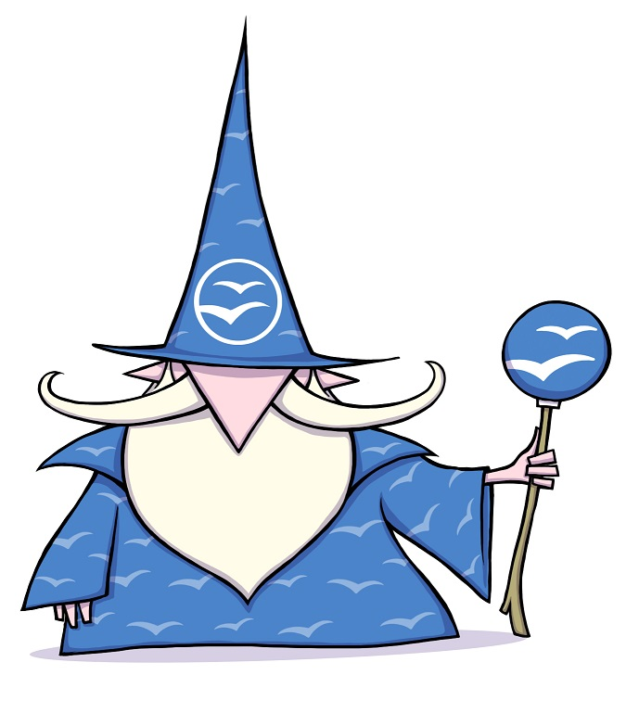
This text content should be wrapping the image. we repeat it quite a few times so you can see the effect.
This text content should be wrapping the image. we repeat it quite a few times so you can see the effect.
This text content should be wrapping the image. we repeat it quite a few times so you can see the effect.
This text content should be wrapping the image. we repeat it quite a few times so you can see the effect.
This text content should be wrapping the image. we repeat it quite a few times so you can see the effect.
This text content should be wrapping the image. we repeat it quite a few times so you can see the effect.
This text content should be wrapping the image. we repeat it quite a few times so you can see the effect.
This text content should be wrapping the image. we repeat it quite a few times so you can see the effect.
This text content should be wrapping the image. we repeat it quite a few times so you can see the effect.
This text content should be wrapping the image. we repeat it quite a few times so you can see the effect.

