A paragraph with a floating image in the middle:
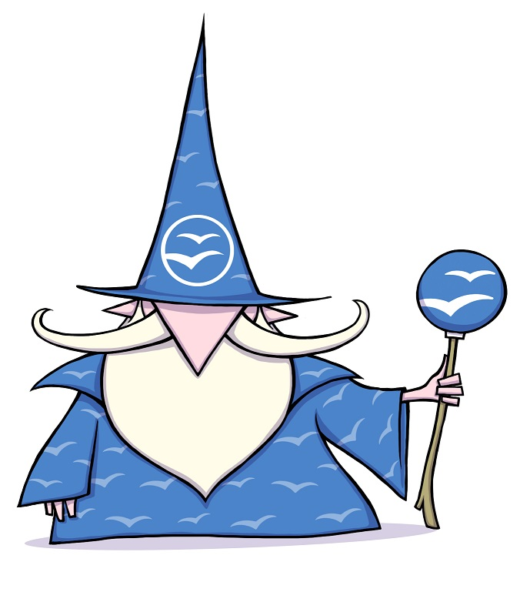
This text content should be wrapping the image. we repeat it quite a few times so you can see the effect. This text content should be wrapping the image. we repeat it quite a few times so you can see the effect. This text content should be wrapping the image. we repeat it quite a few times so you can see the effect. This text content should be wrapping the image. we repeat it quite a few times so you can see the effect. This text content should be wrapping the image. we repeat it quite a few times so you can see the effect. This text content should be wrapping the image. we repeat it quite a few times so you can see the effect. This text content should be wrapping the image. we repeat it quite a few times so you can see the effect. This text content should be wrapping the image. we repeat it quite a few times so you can see the effect. This text content should be wrapping the image. we repeat it quite a few times so you can see the effect. This text content should be wrapping the image. we repeat it quite a few times so you can see the effect. This text content should be wrapping the image. we repeat it quite a few times so you can see the effect. This text content should be wrapping the image. we repeat it quite a few times so you can see the effect. This text content should be wrapping the image. we repeat it quite a few times so you can see the effect. This text content should be wrapping the image. we repeat it quite a few times so you can see the effect. This text content should be wrapping the image. we repeat it quite a few times so you can see the effect. This text content should be wrapping the image. we repeat it quite a few times so you can see the effect. This text content should be wrapping the image. we repeat it quite a few times so you can see the effect. This text content should be wrapping the image. we repeat it quite a few times so you can see the effect. This text content should be wrapping the image. we repeat it quite a few times so you can see the effect. This text content should be wrapping the image. we repeat it quite a few times so you can see the effect.

