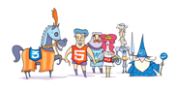
Let us build a paragraph with a few different elements. We include an image drawn by our website illustrator Pablo Matera as well as a clickable link to our website. We hope that this example offers you a good overview of the paragraph method.

