A table used for layout:
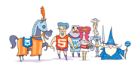 | Some text to the right of this image.
A final paragraph.

