Sample document
Summary. This is a document directly created with the HTML52PDF public API. The document includes a few standard document elements to better illustrate the package functionality.

Some random content
This is a pragraph where we are going to include a couple of elements. Here we include a footnote and also a link to the HTML52PDF website.
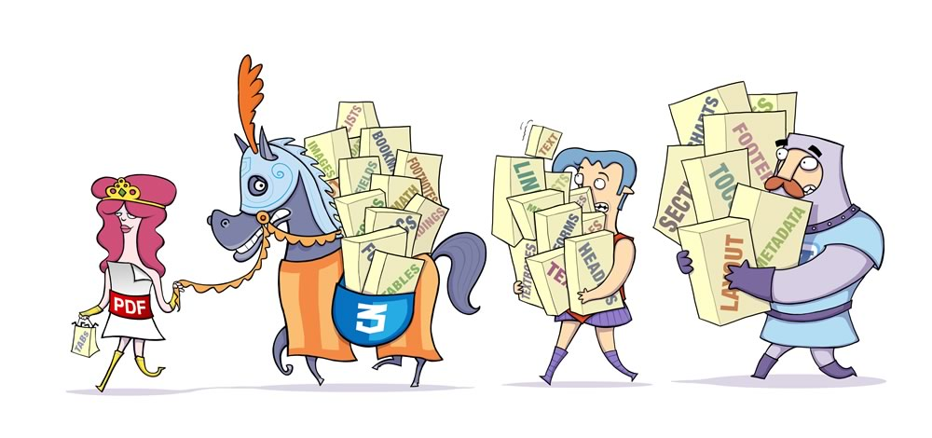

A nice table
Let us include a nicely formatted table:
First column | Second column | Third column
Row 1 | C_1_1 | C_1_2
Row 2 | C_2_1 | C_2_2
Row3 | C_3_1 | C_3_2

A nested list
In order to finish the example a nested list:
- This item has a sublist:
  - SubItem 1
  - SubItem 2
- The final item.

To include a footnote is as simple as this.

