Sample document
Summary. This is a document created out from HTML5 and CSS code. The document includes a few standard document elements to better illustrate the package functionality.

Some random content
This is a paragraph where we are going to include a couple of elements. Here we include a footnote and also a link to HTML52PDF website.
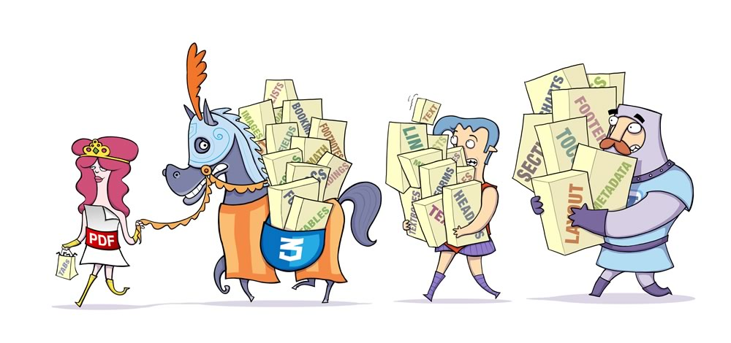

A nice table
Let us include a nicely formatted table:
First Column | Second Column | Third Column
Row 1 | C_1_1 | C_1_2
Row 2 | C_2_1 | C_2_2
Row 3 | C_3_1 | C_3_2

A nested list
In order to finish the example a nested list:
- This item has a sublist:
  - Subitem 1.
  - Subitem 2.
- The final item.

To include a footnote is as simple as this.

